Premiere:
Haitian Precision at EMO2023

The machine tool manufacturer Haitian Precision will present its high-end CNC production technology for the first time at EMO 2023 in Hannover, Germany. Hall 16, Booth D30.

As a member of the successful Haitian Group, Haitian Precision has more than 20 years of experience in the development and production of machining tools and is one of the market leaders in China as a CNC machine manufacturer. Its portfolio includes double-column machines, vertical machines, horizontal machines, and CNC lathes.

One of the reasons for Haitian Precision’s success is its extremely high vertical range of manufacture. 100 percent of machine components are manufactured in-house, from machine beds and linear guides to high-precision electric spindles.

Technology to the point

CNC machines and machining centers of “Hision” – a brand from Haitian Precision - stand for high reliability, fast availability and stable quality – technology to the point, at an outstanding price-performance ratio. The application solutions are in demand, for example, in the automotive, mold making industries, aerospace, general engineering and many more.

Product launch in Germany and Western Europe

Already well established in the Asian economic region, middle east area, mid and south American regions, Haitian Precision is already registering growing interest in Eastern Europe and Serbia in close cooperation with local sales and service partners there. The upcoming debut at the leading trade fair in Hanover now marks the next important step, into the core market of Europe.

EMO exhibits

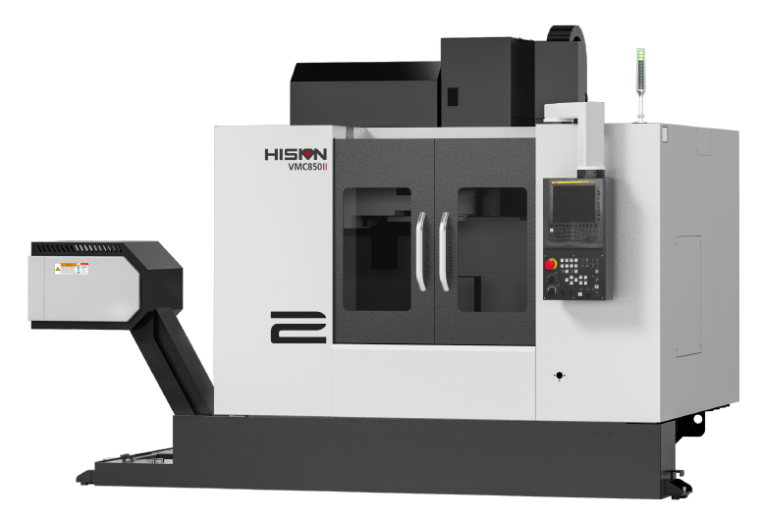

VMC850II

The vertical machining center has an A-shaped structure, with a fixed column and movable table. With highly rigid components and lightweight movable components, the VMC series can perform milling, tapping, drilling, threading, and other processes. The high stability is suitable for high-speed precision machining of small and medium-sized mechanical parts in general engineering, automotive, aerospace, textile machinery industry, etc.

VMC Series live at EMO:

- Travel(X/Y/Z): 850/500/500mm
- Table Max. Load: 600kg
- In-house developed electric spindle with 12,000 RPM (Optional)
- Small footprint, high rigidity
- Low weight of moving parts

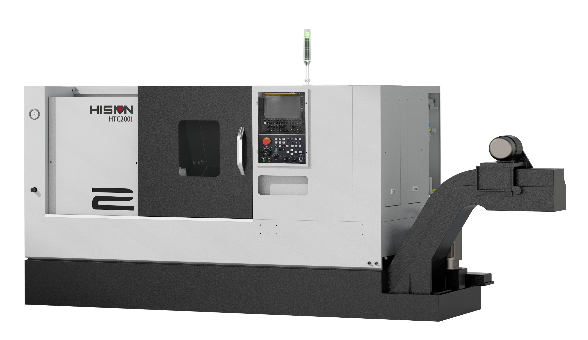

HTC200Ⅱx 560

The HTCII series covers machining diameters from φ300 to φ520 and is especially suitable for high-speed precision machining of small-diameter and short-axis products, for example, in the automotive and aerospace industries.

HTC Series live at EMO:
- Max. swing over the bed: φ620mm
- Max. turning dia.: φ400mm
- Max. turning length: 560mm
- In-house developed electric spindle with max speed up to 4,500 RPM
- In-house developed servo turret
- High precision, efficiency and stability

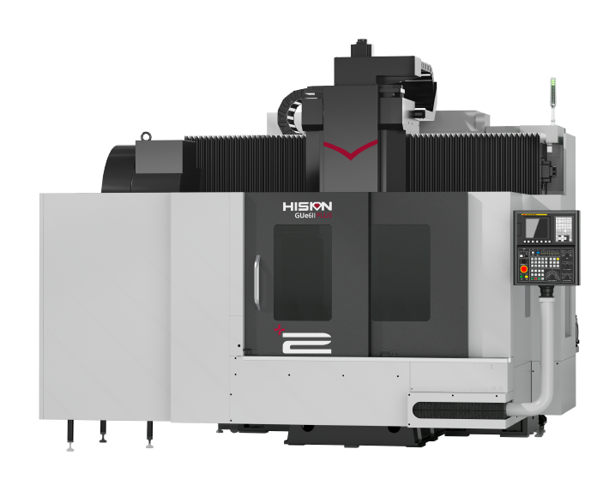

GUe6II PLUS

GUe6II PLUS gantry machining centers are suitable for rough and fine machining of small parts, various kinds of tool shapes, non-ferrous metals and other general machining areas.

GUe6II Plus Series live at EMO:

- Travel(X/Y/Z)：1500/850/700mm
- Rapid traverse(X/Y/Z)： 24/24/15 m/min
- In-house developed electric spindle with max speed up to 8,000 RPM (optional)
- Spindle power：18.5/45kW
- Spindle torque：305/623N•m
- High vibration resistance and thermal stability

About Haitian Precision

Haitian Precision is one of six divisions out of the Haitian Group. Founded in 2002, the Haitian Precision provides research & development, production and sales of medium and high-end CNC machine tools. The production plants in China have a total area of more than 500,000 square meters and have a modernized constant-temperature machining and assembly line. The portfolio includes various kinds of double-column machines, vertical machines, horizontal machines, and CNC lathes . Its solutions are widely applied in industries such as automotive, mold making, aerospace, general engineering, railway and construction machineries.

