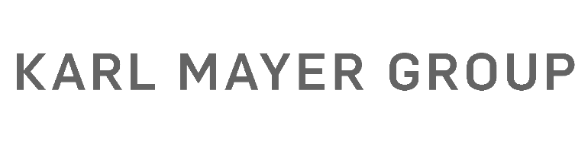
Presseinformation / press release  Postanschrift / post address:  KARL MAYER Gruppe  Industriestraße 1  63179 Obertshausen | Mediakontakt / media contact:  Ulrike Schlenker  Tel.: +49 6104/402-274  E-Mail: ulrike.schlenker@karlmayer.com
Nummer / number: 2372 | Datum / date: 11.08.2022

Learning made even easier now
Digitization of the KARL MAYER Academy

With currently three academies in Germany, China and India, the KARL MAYER Group offers training courses for customers in warp knitting worldwide. The qualification of specialists has a long history with this global player. As early as the early sixties, the first textile technicians were taught knitting know-how at the headquarters in Obertshausen. Today, a wide range of courses is available to customers from all over the world. The traditional location in Hesse is now the first academy to take the next step and offers an online portal for learning.
The so-called Learning Management System (LMS) can be used with immediate effect. After registering, it is possible to book a place here for training in the Academy or a webinar on various topics. There is also another new feature: the first in-house e-learning that can be started directly from the portal. The e-learning entitled “Introduction to Warp Knitting” provides a theoretical introduction to warp knitting. Comprehensive knowledge is imparted on machines, lappings and production calculations.
The use of different media makes the training varied and helps different types of learners to acquire knowledge. “The program was developed by an international team of learning and warp knitting specialists. It gives learners the opportunity to absorb knowledge at their own pace, when and where they want,” explains Sophia Krinner, Product Owner Academy. If desired, a purely practical training course can be booked afterwards to deepen and expand the basic knowledge. Never before has the transfer of knowledge been more efficient for the customer. "We know that our customers can’t afford to keep their employees out of the company for long periods of time, jeopardizing production processes. Our e-learning means that good skilled workers are less likely to be absent from day-to-day operations. They can also learn the practice in a shorter visit than in our previous course models,” says Sophia Krinner. The new e-learning will initially be available in English. The offering will be expanded to include other languages in the coming months. In addition to digital and analog basic courses, the Academy in Obertshausen also offers advanced courses on various topics. Here, tricot, raschel and double raschel machines as well as textile analysis courses are standard.

Access to the LMS and registration for a course is under academy.karlmayer.com/login possible.

Fig.: Product Owner Sophia Krinner presents the e-learning “Introduction to Warp Knitting” to the first interested parties during a product presentation at Techtextil 2022 in Frankfut am Main, Germany.

